Jet engine
ABSTRACT:
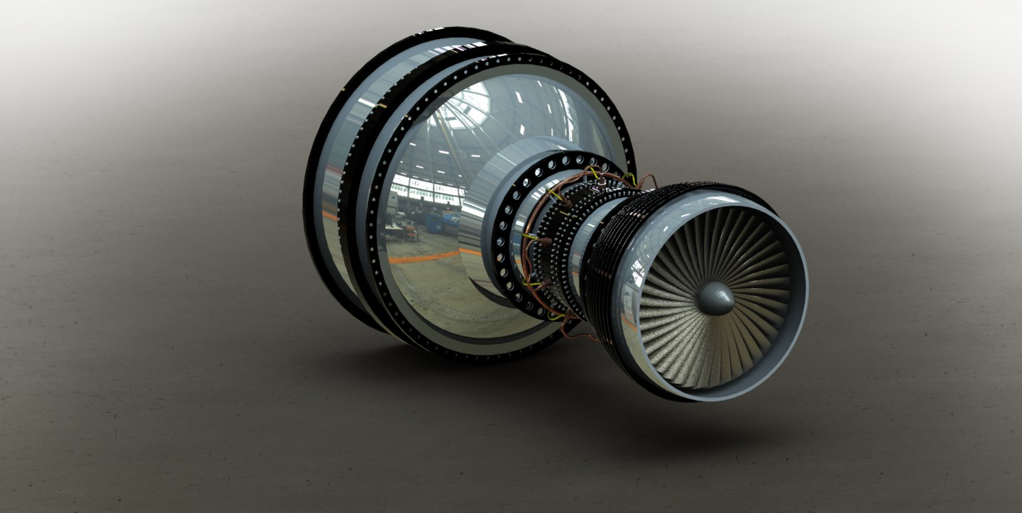
Jet engines are combustion engines which generates thrust by jet propulsion in according to Newton’s law of motion. Jet engines are also combustion engines. When air enters from front through propeller and it is compressed, then forced into combustion chamber. When fuel is sprayed in it and mixture is ignited and the gases expand rapidly and exit out through nozzle. Jet engine moves the aero plane very fast produced by a tremendous force and causes the plane to fly very fast.
The main object of this project is to design a jet engine in SOLID WORKS 2014.

